Adult Fish Release Sites Post-Construction Review Meeting

USACE Block 300 Lewis and Clark Room & Teleconference

August 25, 2014

**Background/Purpose of Meeting**: As part of implementation of the 2008 Willamette BiOp, RPA 4.7 described the need to identify new/improve existing adult fish release sites above Corps dams in the Willamette Basin. Construction work for the release sites identified to be improved took place throughout the spring/summer of 2014. During post-construction site commissioning efforts and discussions with various experts, several items were identified to be further evaluated/refined/considered. The intent of the August 25th meeting was to bring together key people to review the status of each site and discuss what the appropriate path forward is. As part of the meeting, the Corps provided summary of additional hydraulic engineering assessment work and the group reviewed identified issues associated with each site. Attached are the PPT slides provided at the meeting.

**Participants**:

* Corps: Bern Klatte, Jeremy Appt, Steve Schlenker, Tim Kuhn, Dave Leonhardt, Ian Chane, Andrew Traylor.
* USFW: Dan Neff
* NMFS: Jeff Brown
* ODFW/State: Elise Kelley, Cameron Sharpe, Ken Loffink, Bernadette Graham-Hudson, John Thorpe, Dan Peck, Brett Boyd, Greg Grenbemer

**Meeting Discussion Summary**: Jeremy Appt (project Technical Lead) and Steve Schlenker (Hydraulic Engineer) summarized the results of the engineering assessment. This was then followed by a review of the potential issues associated with all release sites. Significant discussion, by the group (in the room and on the phone), took place as part of the review of each site. The following information/tables attempt to summarize those discussions:

**The table below presents a summary of the seven sites that were improved in response to RPA Measure 4.7 of the NMFS BiOp**

|  |  |  |  |
| --- | --- | --- | --- |
| **Sub-Basin** | **River** | **Site Name** | **Current Status** |
| North Santiam | Brietenbush | Villa Maria | Changed river conditions/alternative sites under investigation |
| North Santiam | Brietenbush | USGS Gage | RM&E/ site modifications required before routine use |
| North Santiam | North Santiam | Coopers Ridge | RM&E/ site modifications required before routine use |
| South Santiam | South Santiam | Gordon Road | RM&E/ site modifications required before routine use |
| McKenzie | So Fork McKenzie | Homestead | RM&E/ site modifications required before routine use |
| Middle Fork Willamette | North Fork MFW | Alt Site #1 | Completed/Useable |
| Middle Fork Willamette | Fall Creek | Gold Creek | Completed/Useable |

**North Santiam sub-basin, Breitenbush River**

**Site: USGS Gage Site.**

**Engineering Assessment**: The commissioning of the release site identified several issues:

* pipe slope steepness
* water velocity through pipe
* weight of pipe
* security

The issue with the slope of pipe and potential velocity of water carrying delivering the fish down to the river was discussed. A hydraulic analysis has been completed to assess the velocity concerns (see attached slides). Releasing fish out of a “full” tank will result in velocity above the maximum desired. The analysis showed that if the trucks were not filled to capacity or drained down to about 60% tank volume, the velocity could be reduced below the maximum. The flowing issues were discussed:

* Not clear whether releasing portion of water before releasing fish is viable or better for fish health (Greg Grenbemer indicated crowding would be a problem, Jeremy Appt indicated previous survey of ODFW operations indicated a drawdown was typical, and performed for the purpose of aiding exit from the truck)
* Installation of an eccentric reducer plate on the truck with winch should facilitate release of fish by one person, as opposed to the current two person operation.
* Current pipe is heavy and other types/sizes may need to be considered. The installation of the eccentric reducer plate/wench may alleviate this problem but until in place still a concern. Jeremy Appt indicated that research into other pipes and sizes resulted in no promising candidates.
* Elise Kelley suggested the Corps work closely with staff familiar with operation details. She will provide Jeremy Appt contacts. One name suggested was Marty at ODFW.
* “Dry tank syndrome” was discussed. This is not a new issue but is an ongoing issue with all trucks and release sites. Typically some fish remain in the truck after all water has been released, and requires manually “fishing” the fish out. Pumps and other options were discussed to address this issue. The Corps will not likely address this issue as part of the release site improvement effort since it is a broader concern beyond this particular project.
* Improved security of the release pipe caps and lock system is recommended. Locking systems are an O&M responsibility.
* There was general consensus that some sort of "evaluation” for those adults released at this site will be required in order to fully utilize this site. An RM&E effort will be required; Dave Leonhardt, Bern Klatte and Andy Traylor will investigate appropriate type of evaluation required.
* The centric reducer plate/winch will be completed early next year. No other modifications to the site infrastructure will be implemented until the RM&E effort is scoped and completed.
* During the RM&E period, operations personnel will have to properly deploy and stow the discharge hose at the end of the last cycle for the season, otherwise high water over winter could damage the hose.

**Villa Maria Site:**  This release site was originally identified as a pool. Natural changes in the river during the period between the initial identification and construction filled in the pool with substrate and the pool is now a shallow riffle that is unusable Therefore, this site will not be used until/if pool conditions reoccur. Potential alternative sites are being explored by ODF&W and USFS. The existing pipe can be moved to a new site or stored at the Minto facility until a new site is located.

**Coopers Ridge Site**: This site includes significant infrastructure similar to the USGS site and will require modification to bring into regular use. Current issues are:

Operations personnel expressed an interest in adjusting the angle of incidence of the discharge by a few degrees. This can be accomplished by loosening the bolts on the existing float, and moving the float.

During the RM&E period, operations personnel will have to properly deploy and stow the discharge hose at the end of the last cycle for the season, otherwise high water over winter could damage the hose.

Other alternatives were suggested such as releasing fish into Detroit Reservoir; and improving the existing road to the screw trap location so a fish truck can access it. Road modifications were not supported by USFS at the time site selection occurred. Corps would not oppose others pursuing this option but it could not be funded by the Corps.

**Gordon Road Site**: Commissioning of the site identified a large rock at release site. The release pipe has been realigned and this site is available for use.

|  |  |  |
| --- | --- | --- |
| North Santiam Sub-Basin served by Minto Facility | Pending Infrastructure Changes | Status in Outplanting Program |
| USGS Gage Site  Lower Breitenbush basin | Plate (1), winch (2) and Float Adjustment (3) | Site is usable subject to RM&E and condition assessments of the adults. Incorporate into WVFOP when regional concurrence reached. |
| Villa Maria  Upper Breitenbush basin | Leave concrete block, USACE OD-V to hand carry pipe to alternate location or Minto Facility | Site unusable due to current river conditions. ODFW seeking alternate upper basin site on private land. Legal, Real Estate, and NEPA compliance issues to be determined in consultation with USACE‑PM |
| Coopers Ridge  Lower North Santiam basin | Plate (1), winch (2) and Float Adjustment (3) | Site is usable subject to RM&E and condition assessments of the adults. Incorporate into WVFOP when regional concurrence reached. |
| South Santiam Sub-basin served by Foster Facility | Pending Infrastructure Changes | Status in Outplanting Program |
| Gordon Road – Upper basin site | No pending Changes | Site is usable subject to RM&E and condition assessments of the adults. Incorporate into WVFOP. This is an alternate to the River Bend Site at the County Campground that is primary lower basin site. |
| S.F. McKenzie Sub-Basin served by Cougar Trap and ODFW – Willamette Hatchery | Pending Infrastructure Changes | Status in Outplanting Program |
| Homestead Site – upper SF Mckenzie River | Plate (1), winch (2) and Engineered discharge to reduce angle out (3) | Site is pending infrastructure changes/RM&E in FY15 to determine acceptable use of riffle condition. Regional interest in exploring engineered log jams to build up a pool. This is an alternate to the Slide Creek Truck ramp that is primary lower basin site. |
| North Fork Willamette Sub-basin served by Fall Creek Facility | Pending Infrastructure Changes | Status in Outplanting Program |
| Gold Creek – upper basin truck ramp | No pending Changes. | Site is usable subject to RM&E and condition assessments of the adults. Incorporate into WVFOP. This is an alternate to the Site C truck ramp that is primary lower basin site. |
| N.F. Middle Fork Willamette Sub-Basin served by Willamette Hatchery | Pending Infrastructure Changes | Status in Outplanting Program |
| Alternate Site #1 | No pending changes | Site is usable subject to RM&E and condition assessments of the adults. Incorporate into WVFOP. |

**Details on Pending Infrastructure Changes:**

1. Adapter plate with eccentric reducer intended to reduce adult salmon fetching inside the tank
2. Hand winch on the plate required to render a 1-man operation
3. USACE OD-V can loosen the bolts and adjust the height of the invert up or down.

**Homestead Site**: Site is currently a riffle release condition.

* Eccentric reducer plate, winch and reconfiguration of the pipe outlet and/or float will be evaluated as part of this effort (see sketch below).
* Other options were discussed including construction of an engineered log jam to create pool conditions. Other agencies may explore the viability of this action. The Corps would not pursue this as part of this effort but supports exploration of this action to determine viability.

**Homestead Sketch**

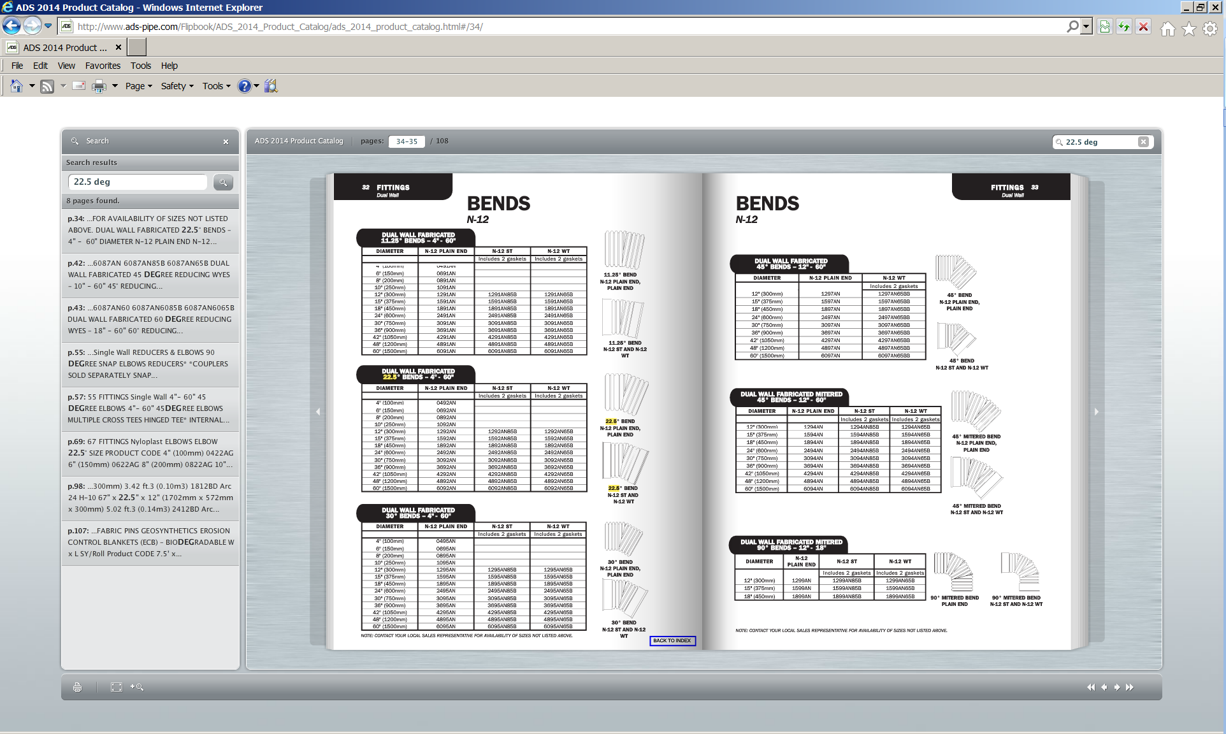

15-inch HDPE 18-inch HDPE 2 fittings

12-inch soft PVC – grey Extend into stream

**Details on Pending Infrastructure Changes:**

1. Adapter plate with eccentric reducer intended to reduce adult salmon fetching inside the tank (USACE Truck Only)
2. Hand winch on the plate required to render a 1-man operation. ODFW can use smaller diameter and lighter weight pipe e.g. 10‑inch discharge hose common. ODFW simply needs to place/replace the 12-inch existing hose when using.
3. Potential Option add mitered bends (22.5 x 2) with clamshell fitting, then slip line entire length with 12-inch diameter soft pvc hose

**Gold Creek Site**: Site is an improved ramp access and usable as is.

**Alternate #1 Site**: Site is usable as is.

**Other Infrastructure Issues:**

Berne Klatte indicated that the current locking devices for the pipe covers are inadequate. OD-V can remedy the locks and bolts as required. The adapter plate with winch is likely to be fabricated under a contract mod with Foster facility, TL - Kristie Fortuny, PM Chris Budai. John Thorpe indicated if through continued use, fetching inside the tank occurs, a site tank and pump may be required to store water for flushing adult salmon that are fetching inside, otherwise a bucket is the S.O.P.

**Overall Site Comments**:

* ODF&W and the USFS are exploring possibility of other release sites. Once assessed they will provide feedback as to viability, etc (landowner approval, site requirements such as building a pool, improved access, etc). See notes on site below.
* The Corps has significant limitations on participating in establishment of new release sites on private lands. If viable alternative sites on private lands are identified: Corps will explore possibility to participate; will explore possibility of other Action Agencies to participate; will work with region on other options.
* The Corps has recognized from the beginning that the purpose of these sites is to provide better options to release fish. Some sites may only be used under certain water conditions and over time it may be that the majority of fish will be released at the reservoirs. Currently, there is a need to establish fish populations in the tributaries with releases in them.
* It was suggested that modifications to sites that don’t meet fish release standards could be acceptable. An example noted was a moderate sloped 12 inch pipe successfully used at Little Fall Creek. In this example, NMFS would relax the 15-inch diameter standard, and minimum flow depth standard, resulting in a long slide.
* All sites will be incorporated into the WVFOP. This effort will require support/leadership from Bern Klatte and his staff.

**Next Steps:**

* Once ODF&W and/or USFS complete assessment of potential “replacement” sites, determine remaining actions for current improved sites. ODF&W has identified site based on initial visit to the site. The site is located on private land owned by the Breitenbush Hotsprings Resort. ODFW obtained permission from the owners to test a temporary release pipe in late August. A suitable pool was found and a temporary pipe was constructed and tested. On 29 August, ODFW with assistance from the UWFS and USACE, successfully released 52 Chinook at this site. The Breitenbush community was supportive of this release site and it will continue to be used for outplanting during the fall of 2014. See attached photos.

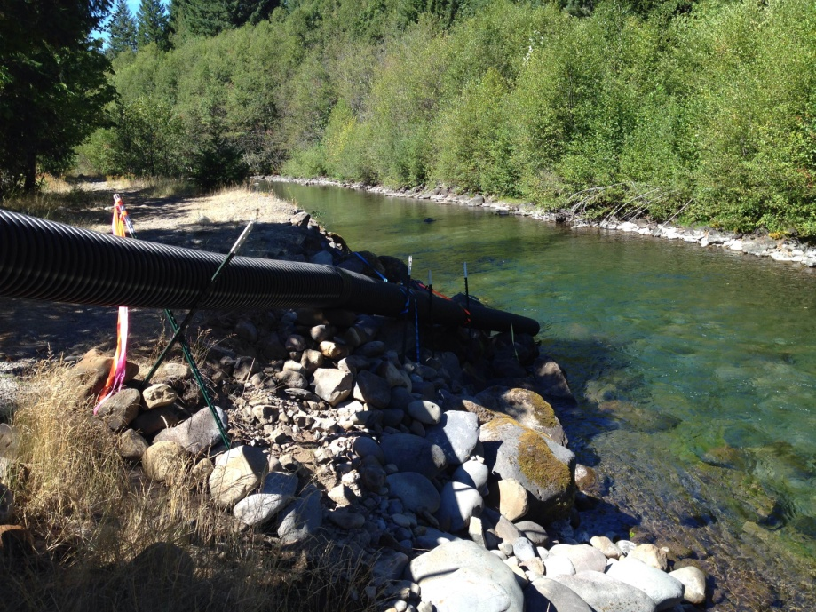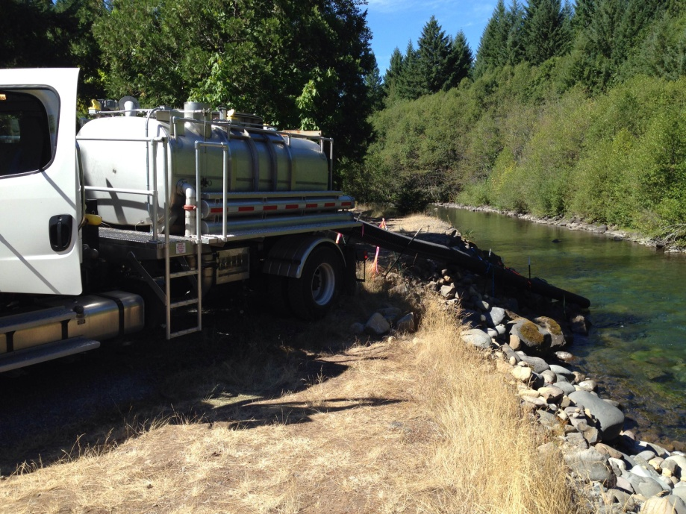

* Modifications such as improved roads, engineered log jams, etc may be evaluated by the appropriate agency and results brought back to the region for consideration.
* If “replacement” sites on private lands are identified, Corps will explore potential involvement.
* Corps to begin incorporating completed sites into the WVFOP with regional agency concurrence and transferring operation/management to appropriate staff.
* Corps to work with ODFW/other on finalizing the design and fabrication of the eccentric plates winches, etc, to begin assessment of them in the field.
* Any RM&E effort required will be coordinated with the Regional interests by Dave Leonhardt, Bern Klatte and Andy Traylor. The appropriate type of evaluations will be developed and funded through the BiOp RM&E program.
* Corps and regional partners to begin exploring appropriate RM&E actions at individual sites to be timed with outplanting in FY 15.
* The existing adult fish release site development team will cease to exist once agreed to actions identified in these meeting notes have been explored and RM&E has been specified. RM&E effort will be carried forward as part of overall RM&E program for implementation of BiOp.